**EMPLOYEE MANAGEMENT SYSTEM**

A

Mini Project Report

Submitted in partial fulfilment of the

Requirements for the award of the Degree of

**BACHELOR OF ENGINEERING**

IN

**COMPUTER SCIENCE & ENGINEERING**

By

**REDDYMALLI NAGARJUN REDDY**

**1602-19-733-148**



**Department of Computer Science & Engineering**

**Vasavi College of Engineering (Autonomous)**

**(Affiliated to Osmania University)**

**Ibrahimbagh, Hyderabad-31**

**2020-21**

**Vasavi College of Engineering (Autonomous)**

**(Affiliated to Osmania University)**

**Hyderabad-500 031**

**Department of Computer Science & Engineering**



**DECLARATION BY THE CANDIDATE**

I, **REDDYMALLI NAGARJUN REDDY,** bearing hall ticket number **1602-19-733-148**, hereby declare that the project report entitled ‘EMPLOYEE MANAGEMENT SYSTEM’,Department of Computer Science & Engineering, VCE, Hyderabad, is submitted in partial fulfilment of the requirement for the award of the degree of **Bachelor of Engineering** in **Computer Science & Engineering**.

This is a record of bona fide work carried out by me and the results embodied in this project report have not been submitted to any other university or institute for the award of any other degree or diploma.

**REDDYMALLI NAGARJUN REDDY,**

**1602-19-733-148.**

**Vasavi College of Engineering (Autonomous)**

**(Affiliated to Osmania University)**

**Hyderabad-500 031**

**Department of Computer Science & Engineering**



**BONAFIDE CERTIFICATE**

Thisis to certify that the project entitled **‘EMPLOYEE MANAGEMENT SYSTEM’** being submitted by **REDDYMALLI NAGARJUN REDDY,** bearing 1602-19-733-148**,** in partial fulfilment of the requirements for the award of the degree of Bachelor of Engineering in Computer Science & Engineering is a record of bona fide work carried out by him/her under my guidance.

**Dr. T. Adilakshmi,**

**Professor & HOD,**

**Dept. of CSE.**

**ACKNOWLEDGEMENT:**

With immense pleasure, we record our deep sense of gratitude to our guide T. Naishita madam, Assistant Professor, Vasavi College of Engineering, Hyderabad, for the valuable guidance and suggestions, keen interest and thorough encouragement extended throughout the period of the project work. We consider ourselves lucky enough to be a part of this project. This project would add as an asset to our academic profiles. We express our thanks to all those who contributed for the successful completion of our project work

# TABLE OF CONTENTS

1. Introduction 6
2. Abstract 6
3. Objective 6
4. System Requirements 7
5. Program 8
6. Output of the Program 13
7. Future work 27
8. References 27

## INTRODUCTION:

Employee Management System is an application that enables users to create and store employee records. This application is helpful to our department or any organization which maintains data of employees.

## ABSTRACT:

* The topic we have chosen for the mini project is Employee Management System.
* Using our project, we try to digitalize existing manual employee records.
* The details of employees we will be storing are name, date of joining, salary, and designation.
* The entered details are placed in a database.
* To achieve that, we make use of sqlite3 module in Python that lets us do database management system operations.
* For GUI, we import tkinter module. In the main menu that appears, there are 4 fields present to add, search, delete and display the employees.
* Once we run the program, we are to provide the required details.
* The ‘filter’ helps us locate a particular credential in a column or the entire database.
* For eg: Add an employee -> Employee Name -> Manjunath

Salary -> 66000

Date of joining -> 30/07/2019

Designation -> xyz

## OBJECTIVE:

The core purpose that is served by computerizing the existing manual system is making stuff paperless and bringing into effect digital records, which is user- friendly and easy to access, as there’s less risk of losing any vital data, given, it’s provided with enough security.

## SYSTEM REQUIREMENTS:

**Hardware:**

* Minimum RAM required: 512 MB
* Minimum disk space required: 50 MB
* Input devices: mouse, keyboard
* Output devices: Monitor

**Software:**

* + Python 3.9.0 (64-bit)
  + Python Launcher
  + DB Browser for SQLite
  + Windows 8.1 or above

## PROGRAM:

import tkinter as tk

import sqlite3

connection=sqlite3.connect("test1.db")

cur=connection.cursor()

try:

cur.execute('''

CREATE TABLE test1 (Name Text,Salary INTEGER,Designation Text,DateOfJoining Text)

''')

except :

pass

def AddEmp() :

addwin=tk.Tk()

addwin.configure(bg='grey')

label2 = tk.Label(master=addwin, text="Add an Employee", fg="white", bg="black", height=3, font=25)

name_var = tk.StringVar(addwin)

sal = tk.StringVar(addwin)

des = tk.StringVar(addwin)

doj = tk.StringVar(addwin)

label2.grid(row=0,pady=10)

name_label=tk.Label(addwin, text = 'Employee Name',pady=10,padx=10, font=('calibre',10, 'bold')).grid(row=2,column=0,pady=10,padx=10)

name_Entry=tk.Entry(addwin,textvariable = name_var, font=('calibre',10,'normal')).grid(row=2,column=1,pady=10)

sal_label = tk.Label(addwin, text='Salary', pady=10, padx=10, font=('calibre', 10, 'bold')).grid(row=3,column=0,pady=10,padx=10)

sal_Entry = tk.Entry(addwin, textvariable=sal, font=('calibre', 10, 'normal')).grid(row=3, column=1,pady=10)

des_label = tk.Label(addwin, text='Designation', pady=10, padx=10, font=('calibre', 10, 'bold')).grid(row=4,column=0,pady=10,padx=10)

des_Entry = tk.Entry(addwin, textvariable=des, font=('calibre', 10, 'normal')).grid(row=4, column=1,pady=10)

doj_label = tk.Label(addwin, text='Date ofJoining', pady=10, padx=10, font=('calibre', 10, 'bold')).grid(row=5,column=0,pady=10,padx=10)

doj_Entry = tk.Entry(addwin, textvariable=doj, font=('calibre', 10, 'normal')).grid(row=5, column=1,pady=10)

sub_btn = tk.Button(addwin, text='Submit', command= lambda :submit(name_var.get(),sal.get(),des.get(),doj.get(),addwin)).grid(row=7,column=1,pady=10)

addwin.mainloop()

def SearchEmp() :

addwin=tk.Tk()

label2 = tk.Label(master=addwin, text="Search an Employee", fg="white", bg="black", height=2, font=14)

label2.grid(row=0,pady=6)

name_var = tk.StringVar(addwin)

name_label=tk.Label(addwin, text = 'Enter the Employee Name',pady=10,padx=10, font=('calibre',10, 'bold')).grid(row=2,column=0,pady=10,padx=10)

name_Entry=tk.Entry(addwin,textvariable = name_var, font=('calibre',10,'normal')).grid(row=2,column=1,pady=10)

sub_btn = tk.Button(addwin, text='Submit', command= lambda :submit_search(name_var.get(),addwin)).grid(row=4,column=1,pady=10)

addwin.mainloop()

def DelEmp() :

addwin=tk.Tk()

label2 = tk.Label(master=addwin, text="Delete an Employee", fg="white", bg="black", height=2, font=14)

label2.grid(row=0,pady=5)

name_var = tk.StringVar(addwin)

name_label=tk.Label(addwin, text = 'Enter the Employee Name',pady=10,padx=10, font=('calibre',10, 'bold')).grid(row=2,column=0,pady=10,padx=10)

name_Entry=tk.Entry(addwin,textvariable = name_var, font=('calibre',10,'normal')).grid(row=2,column=1,pady=10)

sub_btn = tk.Button(addwin, text='Submit', command= lambda :submit_delete(name_var.get(),addwin)).grid(row=4,column=1,pady=10)

addwin.mainloop()

def PrintEmp() :

addwin=tk.Tk()

label2 = tk.Label(master=addwin, text=" Employee list", fg="white", bg="black", height=2, font=14)

label2.grid(row=0,pady=6)

rows = cur.execute(''' SELECT Name, Salary,Designation,DateOfJoining FROM test1 ''').fetchall()

print(rows)

row_number=2

for row in rows:

names,salary,designation,doj=row[0],row[1],row[2],row[3]

employee_details=tk.Label(addwin,text=' Name: '+ names+'\t Salary: '+str(salary)+'\t Designation: '+designation+' \t Date Of Joining: '+doj,pady=10,padx=10, font=('calibre',10, 'bold')).grid(row=row_number)

row_number+=1

addwin.mainloop()

def submit(name,sal,des,doj,addwin):

print(name + sal)

cur.execute('''INSERT INTO test1 VALUES (?,?,?,?) ''',(name,sal,des,doj))

connection.commit()

rows = cur.execute(''' SELECT Name, Salary,Designation,DateOfJoining FROM test1 ''').fetchall()

print(rows)

addwin.destroy()

sub_win=tk.Tk()

row_number=0

for row in rows:

names,salary,designation,DOJ=row[0],row[1],row[2],row[3]

employee_details=tk.Label(sub_win,text=' Name: '+ names+'\t Salary: '+str(salary)+'\t Designation: '+designation+' \t Date Of Joining: '+doj,pady=10,padx=10, font=('calibre',10, 'bold')).grid(row=row_number)

row_number+=1

def submit_search(name,addwin):

details = cur.execute(''' SELECT Name,Salary,Designation,DateOfJoining From test1 WHERE Name = (?) ''',(name,)).fetchall()

print(details)

addwin.destroy()

def submit_delete(name,addwin):

cur.execute(''' DELETE From test1 WHERE Name = (?) ''',(name,))

#print(details)

addwin.destroy()

connection.commit()

window = tk.Tk()

window.geometry=("400x200")

window.configure(bg='grey')

# label=tk.Label(text="Employee management",fg="red",bg="black",width=2,height=2)

label = tk.Label(master=window,text="Employee Management System", fg="white", bg="black",height=3,font=("Times New Roman",25,'bold'))

label.pack()

b1=tk.Button(window,text="Add an employee",command=AddEmp,fg="red", bg="black",height=1,font=14 , pady=0,padx=0,activebackground='yellow')

b1.pack(pady=5)

b2=tk.Button(window,text="Search an employee",command=SearchEmp,fg="red", bg="black",height=1,font=14 , pady=0,padx=0,activebackground='yellow')

b2.pack(pady=5)

b3=tk.Button(window,text="Delete an employee",command=DelEmp,fg="red", bg="black",height=1,font=14 , pady=0,padx=0,activebackground='yellow')

b3.pack(pady=5)

b4=tk.Button(window,text="view all employees",command=PrintEmp,fg="red", bg="black",height=1,font=14 , pady=0,padx=0,activebackground='yellow')

b4.pack(pady=5)

window.mainloop()

# OUTPUT:

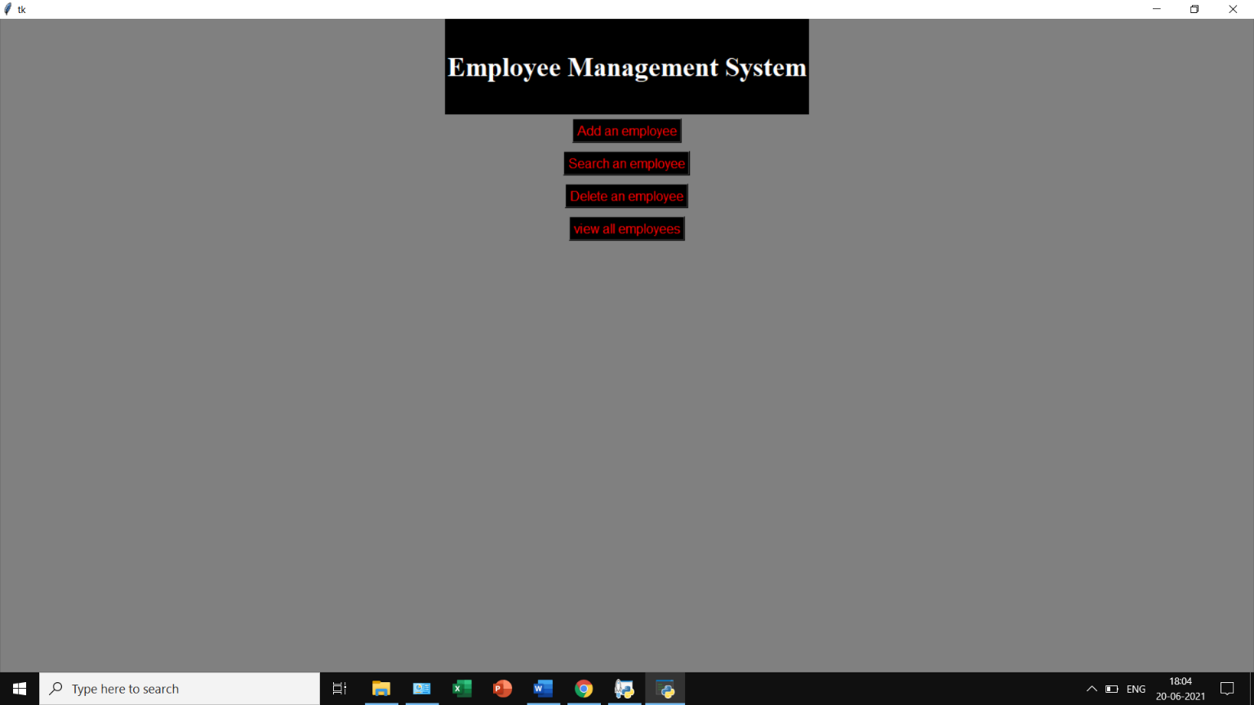

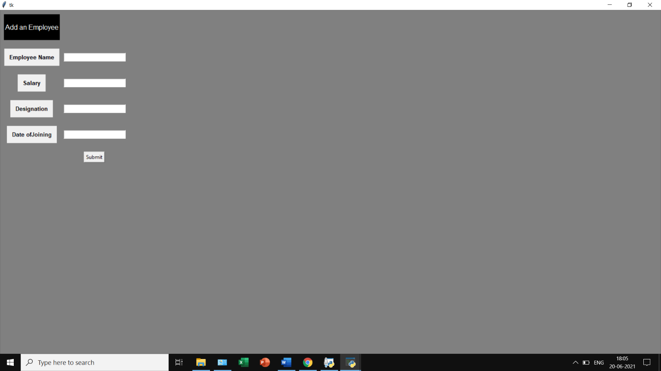

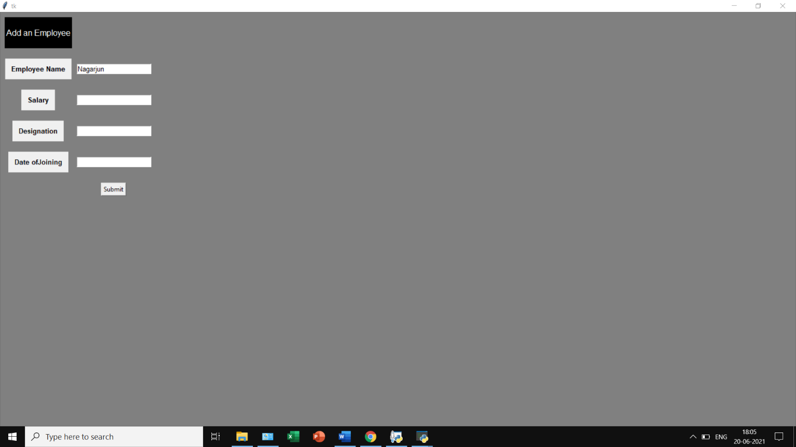

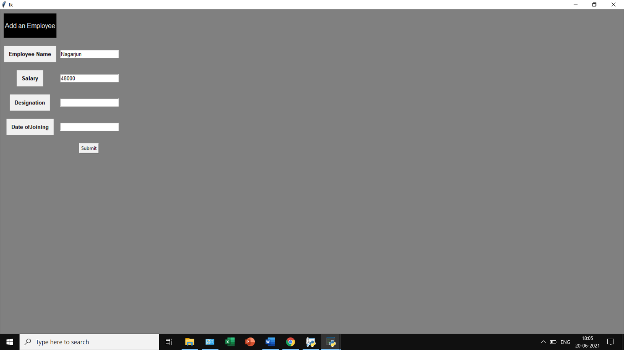

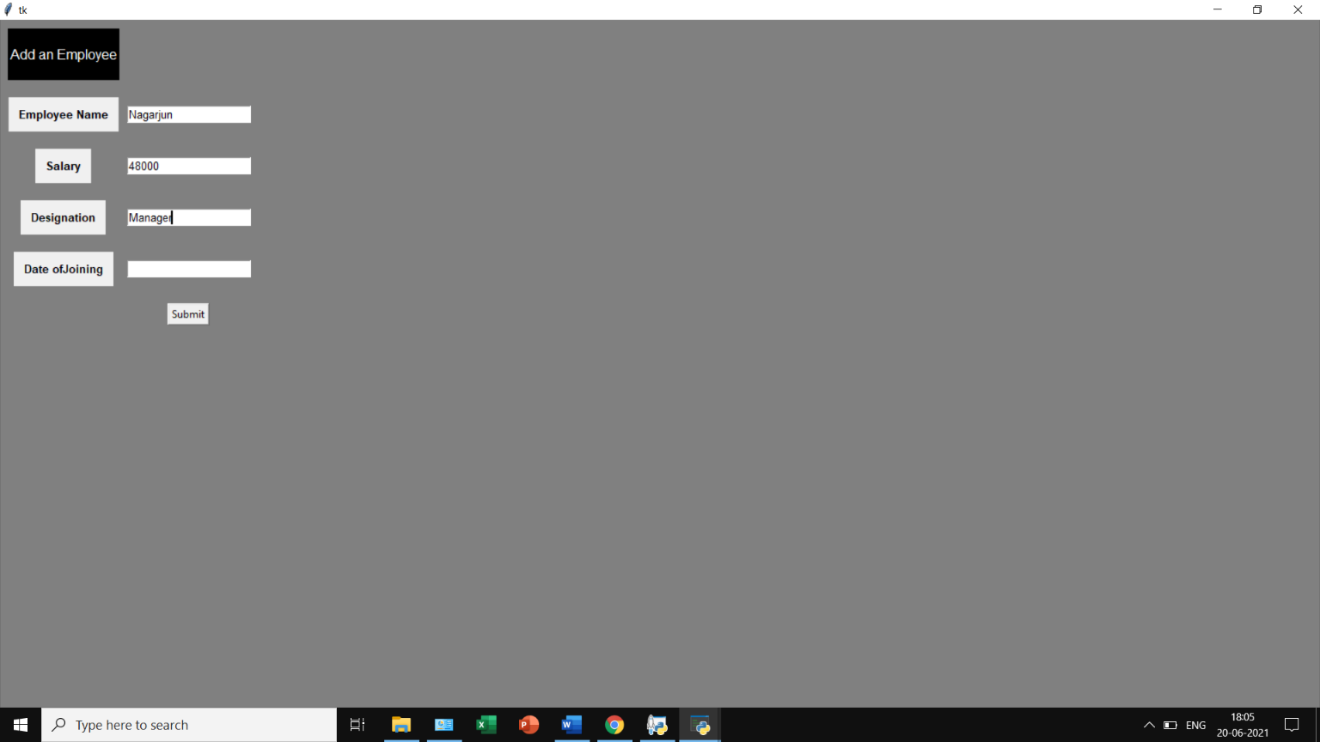

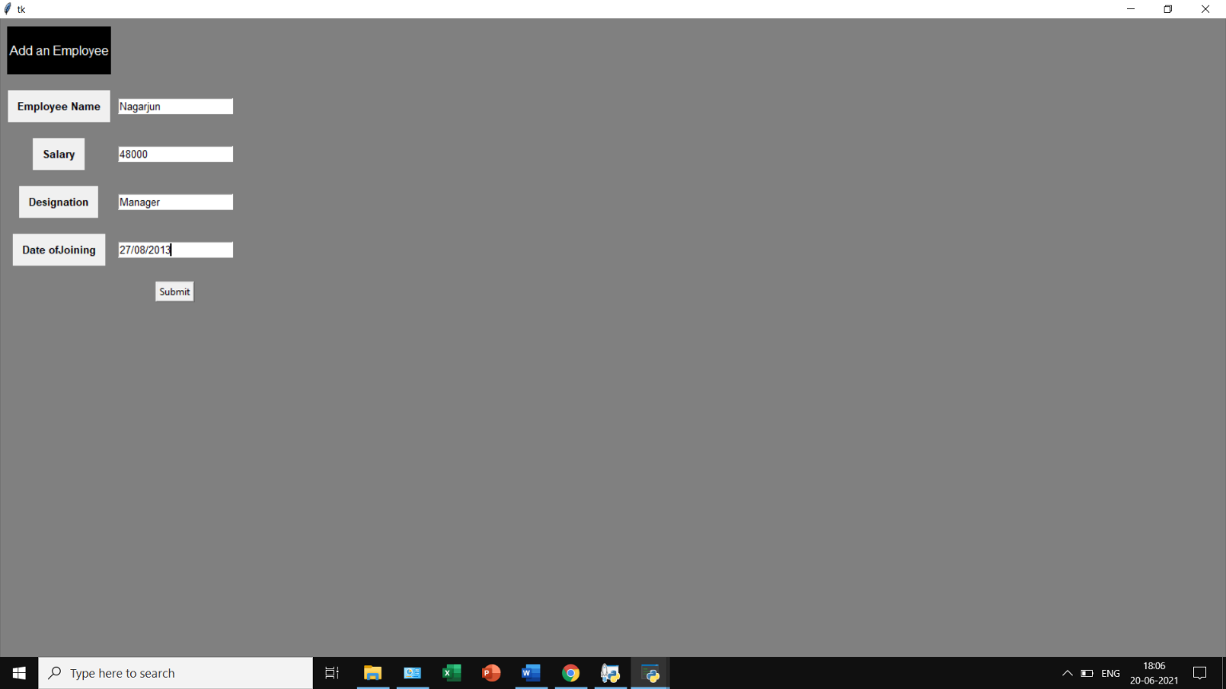

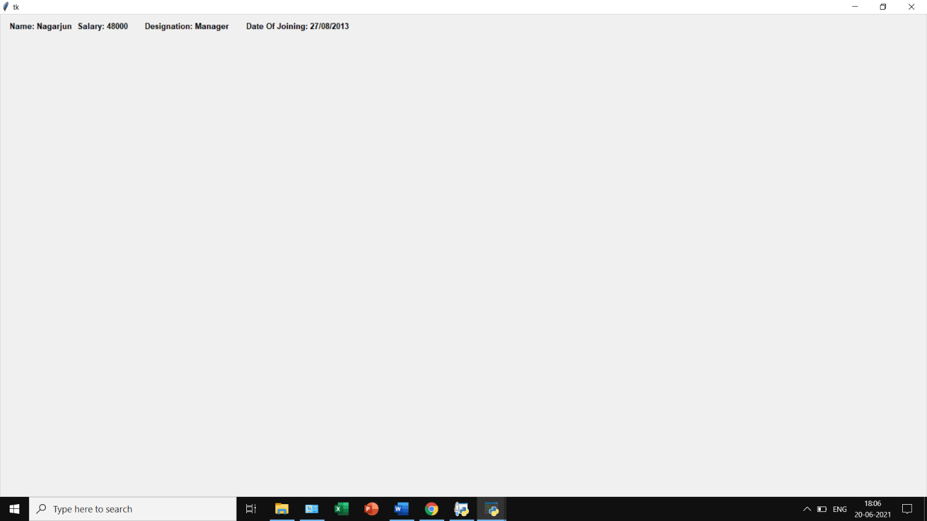

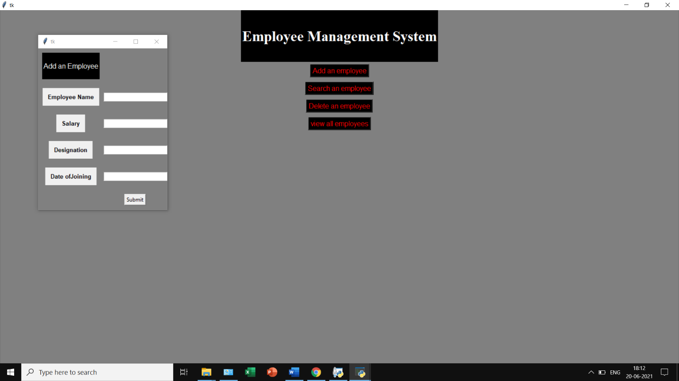

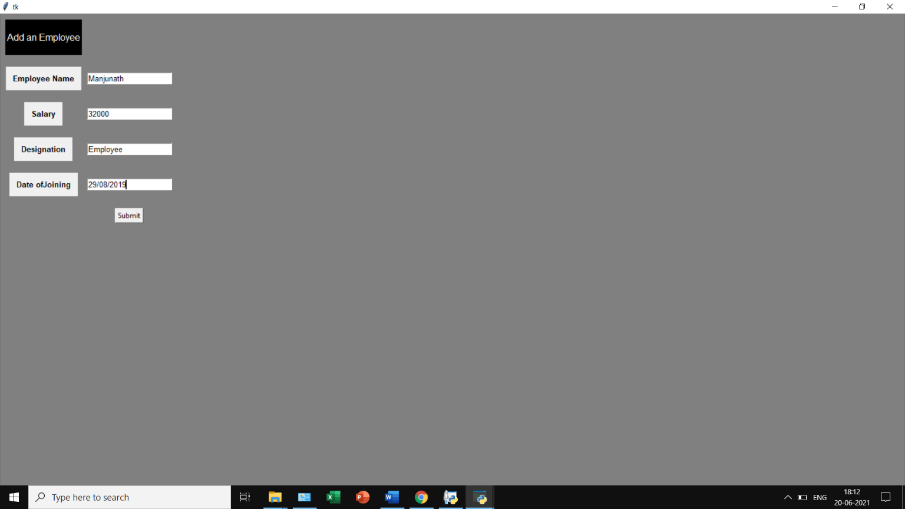

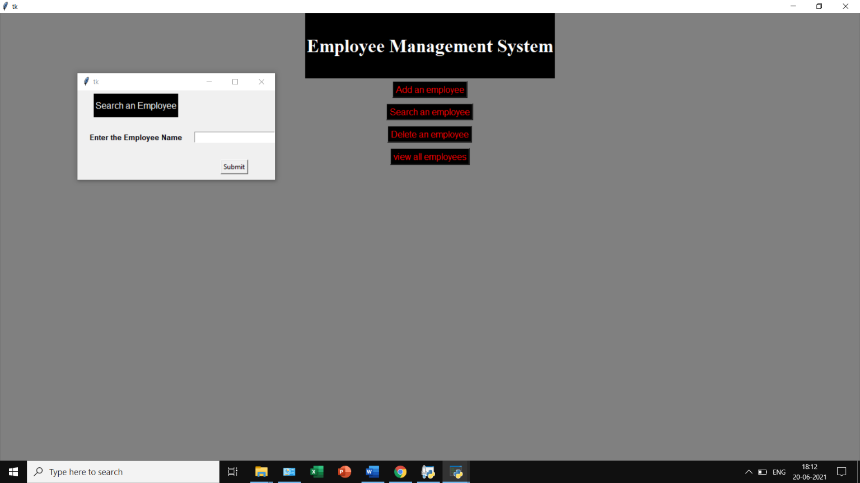

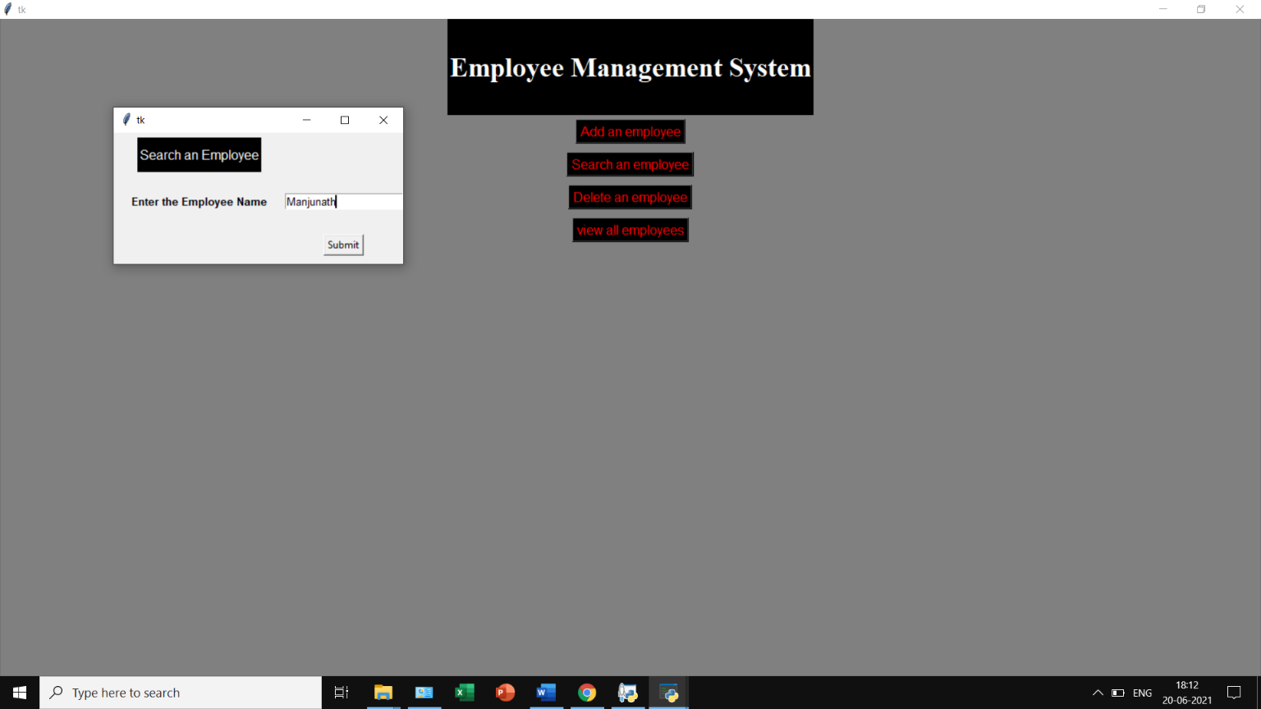

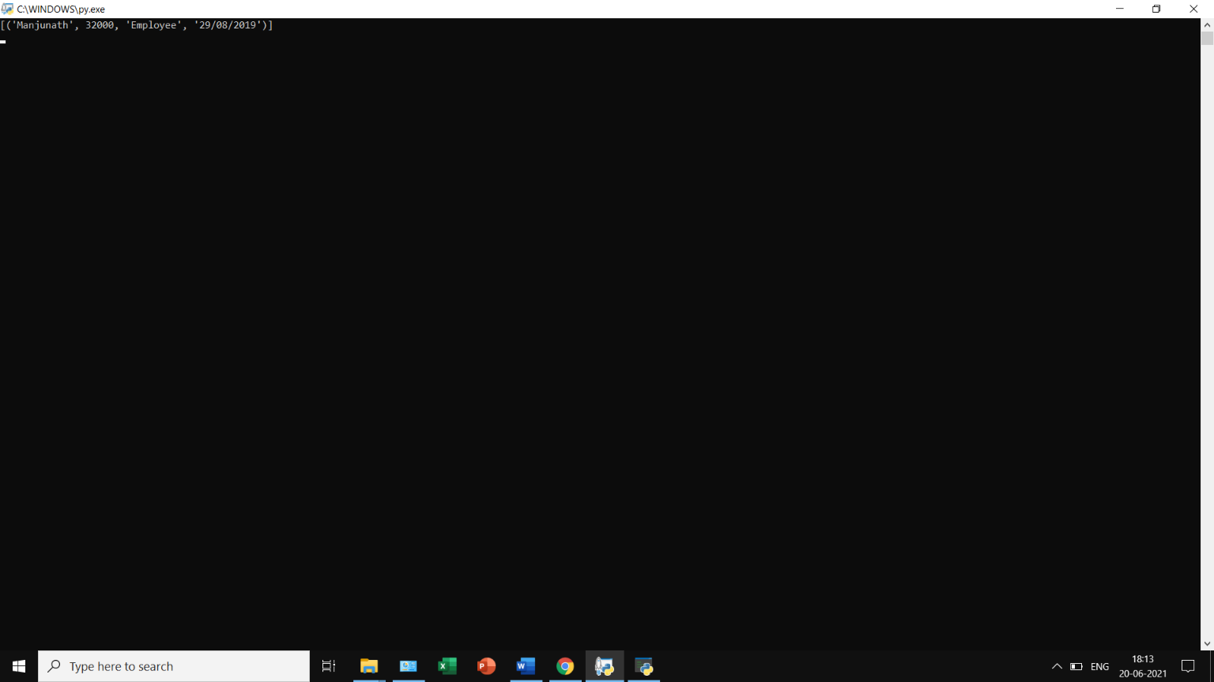

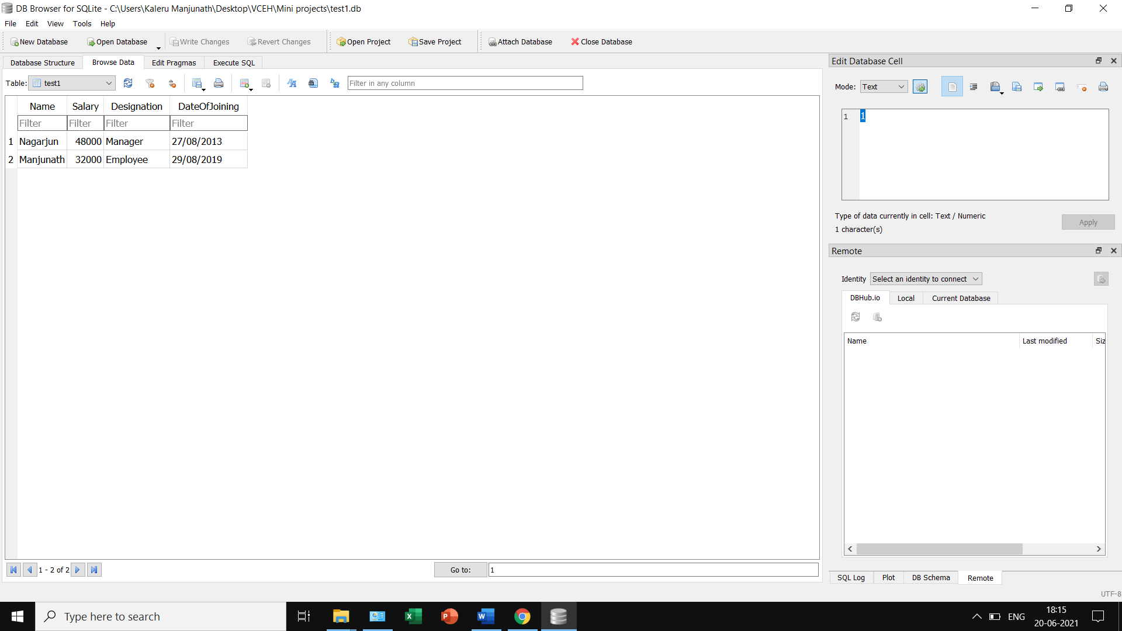

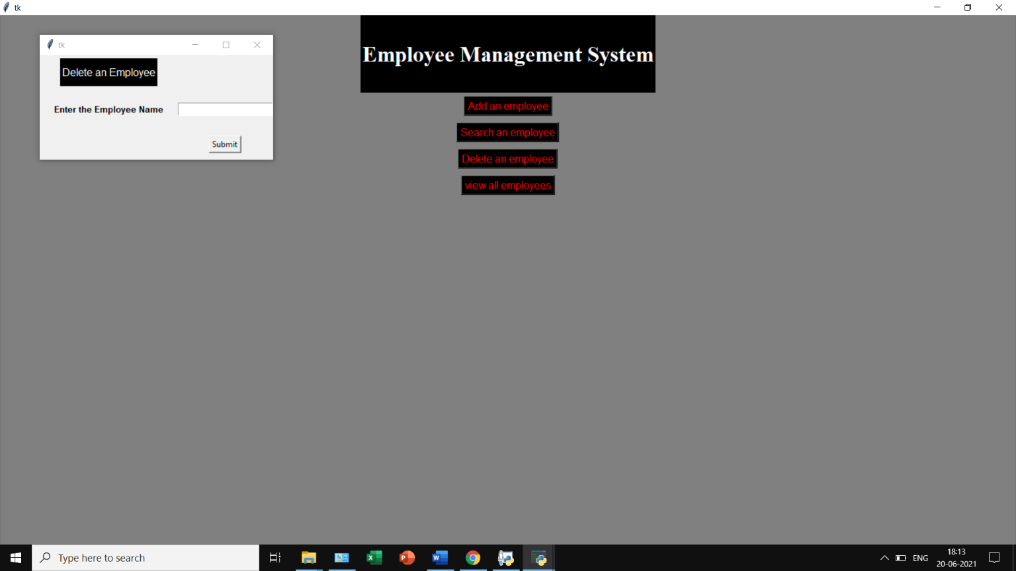

## 

## 

## FUTURE WORK:

We will be linking this project with file handling and extend the storage for some additional details as well to give it a comprehensive look, ready for service.

## REFERENCES:

* https://www.tutorialspoint.com/index.htm
* <https://www.w3schools.com/>
* <https://www.javatpoint.com/>
* https://[www.geeksforgeeks.com/](http://www.geeksforgeeks.com/)
* https://[www.programiz.com/](http://www.programiz.com/)
* SWAYAM - NPTEL